**ATAR HUMAN BIOLOGY – UNIT 4**

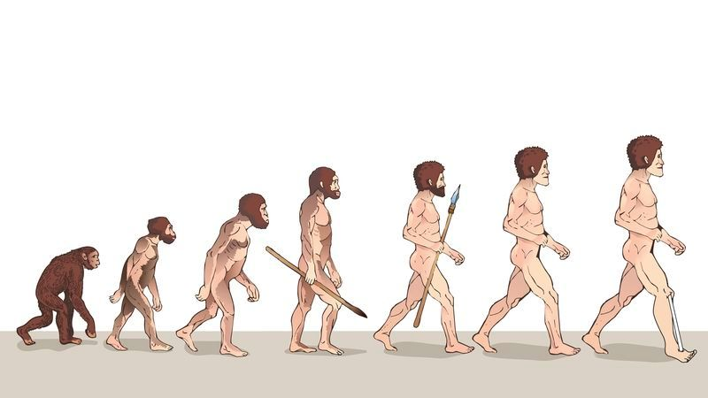**TASK 11 – Investigation into Fossils**

**NAME:_____________________________________ WEIGHTING: 2% MARK: _______**

**Aim:** **To be able to describe how humans have evolved over time**

Having survived for millions of years until they were found, hominin skulls provide irrefutable evidence for human evolution. During this lab you are going to be challenged to become the paleoanthropologists and discover facts about human evolution from guided observations and measurements of skull replicas. You are going to collect information, interpret the results and discuss how human evolved. The skulls you are using are replicas of ones that have been found and the details of their discoveries are included.

**Materials Provided**

Hominin skulls

Protractor

Calipers

Discovery information

**Procedure**

1. Read through the handout notes about paleoanthropology.
2. Watch the demonstration of how to measure the skull
3. Each station has a skull, a set of calipers and a protractor. Visit each station and measure the following recording your results in the table. *(3 marks)*

**Measurement 1**:

Foramen Magnum Introduction: Bipedalism is a unique trait to hominins, it is certain that early hominins were walking as evidenced at the Laetoli site, a well-preserved series of footprints covered in volcanic ash that’s well dated to 3.6 million years ago.

To compare skulls for bipedalism, scientists calculate the opisthion index. This is done by measuring the distance from the foramen magnum to the opisthiocranion, then compare it to the total skull length. The opisthion is the rear most point of the foramen magnum.

An oisthion index value greater than 15 means that the foramen magnum is situated close to the center of the cranium. This position is found in species that **stand upright** and demonstrates bipedalism. An opisthion index less than 15 means the foramen magnum is situated more in the rear of the cranium. This position is found in species that walk on their knuckles or on all four legs.

Read the explanation sheet for measurement 1, take your measurements and record in your table.

**Measurement 2: Maxillary Prognathism**

In this section the degree of maxillary prognathism will be measured using a protractor. The teeth and the bones around the mouth provide a great deal of information about both a species’ diet and how it eats. This exercise concerns the maxilla, a two-bone fusion that forms the upper jaw. Facial prognathism is the extent to which the face and jaws protrude forward when looking at the skull from the side.

Read the explanation sheet for measurement 2, take your measurements and record in your table.

**Measurement 3: Cranial Capacity**

The brain is housed inside the cranium. The interior volume of the cranium is called the cranial capacity. This section facilitates the measurement of the cranial capacity. Homo sapiens, cranial capacity varies widely from 1200cc (cubic centimeters) to 2000cc with each level of intelligence on either end.

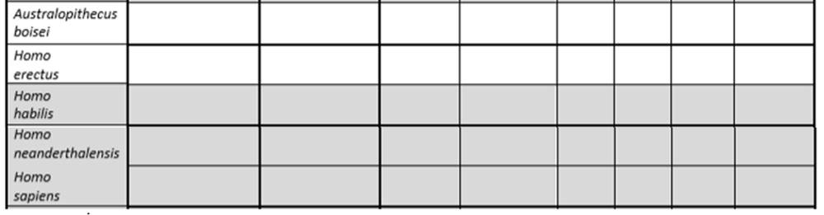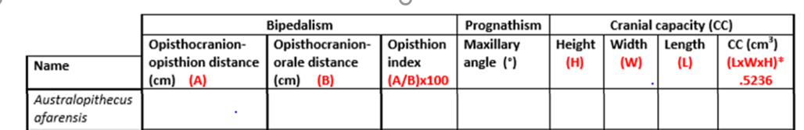Read the explanation sheet for measurement 3, take your measurements and record in your table.

Using the information, you have gained graph your results for Cranial capacity only. *(5 marks)*

|  |  |  |  |  |  |  |  |  |  |  |  |  |  |  |
| --- | --- | --- | --- | --- | --- | --- | --- | --- | --- | --- | --- | --- | --- | --- |
|  |  |  |  |  |  |  |  |  |  |  |  |  |  |  |
|  |  |  |  |  |  |  |  |  |  |  |  |  |  |  |
|  |  |  |  |  |  |  |  |  |  |  |  |  |  |  |
|  |  |  |  |  |  |  |  |  |  |  |  |  |  |  |
|  |  |  |  |  |  |  |  |  |  |  |  |  |  |  |
|  |  |  |  |  |  |  |  |  |  |  |  |  |  |  |
|  |  |  |  |  |  |  |  |  |  |  |  |  |  |  |
|  |  |  |  |  |  |  |  |  |  |  |  |  |  |  |
|  |  |  |  |  |  |  |  |  |  |  |  |  |  |  |
|  |  |  |  |  |  |  |  |  |  |  |  |  |  |  |
|  |  |  |  |  |  |  |  |  |  |  |  |  |  |  |
|  |  |  |  |  |  |  |  |  |  |  |  |  |  |  |
|  |  |  |  |  |  |  |  |  |  |  |  |  |  |  |
|  |  |  |  |  |  |  |  |  |  |  |  |  |  |  |
|  |  |  |  |  |  |  |  |  |  |  |  |  |  |  |

**Analysis & Discussion (28 marks)**

1. Describe the trends evident from the data for each measured feature. *(3 marks)*

_____________________________________________________________________________________

_____________________________________________________________________________________

_____________________________________________________________________________________

_____________________________________________________________________________________

_____________________________________________________________________________________

_____________________________________________________________________________________

_____________________________________________________________________________________

_____________________________________________________________________________________

_____________________________________________________________________________________

1. Comment on which species you infer were bipedal and, suggest a connection between the change in the feature that determined bipedalism and how it helped the species evolve. *(3 marks)*

_____________________________________________________________________________________________________________________________________________________________________________________________________________________________________________________________________________________________________________________________________________________________________________________________________________________________________________________________________________________________________________________________________________________________________________________________________________________________________________________________________________________________________________________________________________________________________________________________

1. Looking at the skulls as a whole, what other traits correspond with those species which have protruding upper jaws? Give an explanation why the features may go together. *(2 marks)*

____________________________________________________________________________________________________________________________________________________________________________________________________________________________________________________________________________________________________________________________________________________

1. Compare the size of the cranial vault in the Australopithecus species with that of the Homo species. How do you infer this would have helped the species evolve? *(2 marks)*

______________________________________________________________________________________________________________________________________________________________________________________________________________________________________________________________________________________________________________________________________________________________________________________________________________________________________________________________________________________________________________________________

Due to the predicted age of the skulls that have been found, different dating techniques would need to be used to give an age for the fossils.

1. Compare and contrast radiocarbon dating with potassium-argon dating. *(6 marks)*

______________________________________________________________________________________________________________________________________________________________________________________________________________________________________________________________________________________________________________________________________________________________________________________________________________________________________________________________________________________________________________________________________________________________________________________________________________________________________________________________________________________________________________________________________________________________________________________________________________________________________________________________________________________________________________________________________________________________________________________________________________________________________________________________________________________________________________________________________________________________________________________________________________________________________

1. Fossil skulls such a *Australopithicus Afarensis* (Lucy) would require a different dating technique to the Homo Sapien skull. Explain what relative dating techniques could be used to try and give a relative date for the skull.  *(4 marks)*

_______________________________________________________________________________________________________________________________________________________________________________________________________________________________________________________________________________________________________________________________________________________________________________________________________________________________________________________________________________________________________________________________________________________________________________________________________________________________________________________________________________________________________________________________________________________________________________________________________________________________________________________________________________________________________________________________________________________________________

Three Hominins were killed in different circumstances during a volcanic eruption. They were:

1. While foraging for food on the volcanically active mountain, a woman was instantly covered in volcanic ash.
2. When trying to escape for the lava, a young boy fell into a fast-flowing river.
3. After the eruption, a hunting group returned to their decimated village. They were poisoned by the sulfur dioxide and died on the surface.
4. Explain which of the above scenarios would lead to the best-preserved fossil, and why the other two would likely not make fossils. *(5 marks)*

________________________________________________________________________________________________________________________________________________________________________________________________________________________________________________________________________________________________________________________________________________________________________________________________________________________________________________________________________________________________________________________________________________________________________________________________________________________________________________________________________________________________________________________________________________________________________________________________________________________________________________________________________________________________________________________________________________________________________________________________________________________________________________________________________________________________________________________________________________________________________________________________________________________________________________________________________________________________________________________________________________________________________________________________________________

**Discussion of results and interpretation**

1. Describe the trends evident from the data for each measured feature. (3 marks)

|  |  |
| --- | --- |
| **Description** | **Marks** |
| The older the species the smaller the cranial capacity – except *Homo* *neanderthal* which had a larger capacity than *Homo sapien* | 1 |
| Opisthion index increases slightly /Forearm magnum moves further towards centre the younger the fossils get | 1 |
| The older the fossil the smaller the maxillary angle gets/increased prognathism | 1 |
|  | **Total /3** |

1. Comment on which species you infer were bipedal and, suggest a connection between the change in the feature that determined bipedalism and how it helped the species evolve. (3 marks)

|  |  |
| --- | --- |
| **Description** | **Marks** |
| All species were bipedal as have a opisthion index of more than 15. | 1 |
| Became better at standing on two feet - | 1 |
| Reason for evolving – could run from danger better so survived, could move bigger distances to find food etc | 1 |
|  | **Total /3** |

1. Looking at the skulls as a whole, what other traits correspond with those species which have protruding upper jaws? Give an explanation why the features may go together. (2 marks)

|  |  |
| --- | --- |
| **Description** | **Marks** |
| More protruding the upper jaw the bigger the teeth/bigger arch on side of head/thick mandible or jaw | 1 |
| Teeth big so jaw needs to be larger to accommodate/big muscles needed to move big teeth/jaw – a logical connection | 1 |
|  |  |
|  | **Total** |

1. Compare the size of the cranial vault in the Australopithecus species with that of the Homo species. How are they different? (2 marks)

|  |  |
| --- | --- |
| **Description** | **Marks** |
| They are much smaller/increase in size as species evolve | 1 |
| Brain capacity linked to intellect – became smarter so could start building tools to kill things/build shelters to help survive/be curious to move out of Africa – any logical reasoning as to how it may help species evolve | 1 |
|  |  |
|  | **Total** |

Due to the predicted age of the skulls that have been found, different dating techniques would need to be used to give an age for the fossils.

1. Compare and contrast radiocarbon dating with potassium-argon dating. *(6 marks)*

|  |  |
| --- | --- |
| **Description** | **Marks** |
| Carbon dating - fossil organic, potassium argon must have volcanic sediment | 1 |
| Carbon date less than 70,000 years old, potassium argon between 100,000-200,000 | 1 |
| When die the ratio of C14 to C12 would be fixed, when sediment made ratio fixed | 1 |
| C14 deteriates to nitrogen, potassium deteriates to argon and calcium | 1 |
| It takes 5730 years for C14 to halve, takes 1.26-1.4million years for K40to halve | 1 |
| Look at ratio of c14 to C12 left . look at ratio of K40 :Ar40 | 1 |
| At least one of the following: | |
| Both rely on the ratio of the radioactive isotope being predictable when fossil made | 1 |
| Both calculate age of fossil using half-life value and the ratio of chemicals left in the specimen | 1 |
|  | **Max /6** |

1. Fossil skulls such a *Australopithicus Afarensis* (Lucy) would require a different dating technique to the Homo Sapien skull. Explain what relative dating techniques could be used to try and give a relative date for the skull.  *(4 marks)*

|  |  |
| --- | --- |
| **Description – first two marked, could be either:** | **Marks** |
| Strategraphy – the deeper the fossil the older it is by law of superposition | 1-2 |
| If know the age of fossil in another layer can say if skull is older or younger than |
| If found with an index fossil can age the skull | 1-2 |
| Index fossils are species that were abundant but only around for short time so know age roughly |
| Can look at the layers of the rock around the fossil and match with a similar layer arrangement from elsewhere | 1-2 |
| If fossils aged in other stratigraphic column can assume skull is similar age |
|  | **Max /4** |

Three Hominins were killed in different circumstances during a volcanic eruption. They were:

1. While foraging for food on the volcanically active mountain, a woman was instantly covered in volcanic ash.
2. When trying to escape for the lava, a young boy fell into a fast-flowing river.
3. After the eruption, a hunting group returned to their decimated village. They were poisoned by the sulfur dioxide and died on the surface.
4. Explain which of the above scenarios would lead to the best-preserved fossil, and why the other two would likely not make fossils. *(6 marks)*

|  |  |
| --- | --- |
| **Description** | **Marks** |
| 3 marks stating why choose one scenario, one mark each for why others would not be as good. | |
| When fell into river he was completely whole and undisturbed | 1 |
| He would of being covered with sediment quickly | 1 |
| The river would have been cold so less decay | 1 |
| i. the volcanic ash is very hot and would of burnt the woman so nothing left to become a fossil | 1 |
| iii. when poisoned the people would have been left lying around so likely to have been eaten by predators so when fossilized fossil would be incomplete/likely reason | 1 |
|  | **Total /5** |